Analysis

## Fundamentals

Based on data to every student's math and reading scores, as well as various information on the schools they attend. The task is to showcase obvious trends in school performance.

## Specifications

Write a report that summarizes the analysis and draws two correct conclusions or comparisons from the calculations.

See below different summaries of the data:

## Rating based on spending ranges of schools made per student number

## Rating by School Size based on number of students

## Rating based on School Type

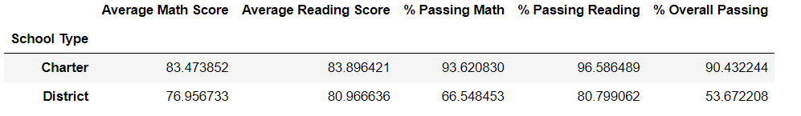

Using data from three set of results, it appears that the higher the amounts of investment in schools, the lower the grades from students. As an example a school with budgets smaller than USD 585 have on average passing scores of 83 and 96 for math and reading subjects; unlike schools with budgets above USD 645, whose scores at math and reading are 76 and 81 on average too.

In addition, we observed a similar trend in terms of schools size, where those with small and medium size based on number of students do get better scores than large ones. Although the difference at reading is imperceptible (i.e. 2 points), the gap at math is greater with up to 6 points.

Last, a charter school[1] presents higher scores in both math and reading, than a district school[2], with differences of up to 6 points in the first and up to 3 points in the latter. This may be associated to the fact that charter add more options and different models of schools to the system, which usually gives parents more variety of choices. i,ii

1. *What is a charter school?* National Alliance for Public Charter Schools. (n.d.). Retrieved February 6, 2023, from https://www.publiccharters.org/about-charter-schools/what-charter-school
2. *District school definition*. Law Insider. (n.d.). Retrieved February 6, 2023, from https://www.lawinsider.com/dictionary/district-school